**Interview Questions of HTML5**

HTML 5 is a new standard for HTML whose main target is to deliver everything without need to any additional plugins like flash, Silverlight etc.

What were some of the key goals and motivations for the HTML5 specification?

HTML5 was designed to replace both HTML 4, XHTML, and the HTML DOM Level 2.

* Deliver rich content (graphics, movies, etc.) without the need for additional plugins (e.g., Flash).
* Provide better semantic support for web page structure through the introduction of new structural element tags.
* Provide better cross-platform support (i.e., to work well whether running on a PC, Tablet, or Smartphone).

What are some of the key new features in HTML5?

* Improved support for embedding graphics, audio, and video content via the new [<canvas>](http://www.w3schools.com/tags/tag_canvas.asp" \t "_blank), [<audio>](http://www.w3schools.com/tags/tag_audio.asp" \t "_blank), and [<video>](http://www.w3schools.com/tags/tag_video.asp" \t "_blank) tags.
* Extensions to the JavaScript API such as [geolocation](http://www.w3schools.com/html/html5_geolocation.asp" \t "_blank) and [drag-and-drop](http://www.w3schools.com/html/html5_draganddrop.asp" \t "_blank) as well for [storage](http://www.w3schools.com/html/html5_webstorage.asp" \t "_blank) and [caching](http://www.w3schools.com/html/html5_app_cache.asp" \t "_blank).
* Several new semantic tags were also added to complement the structural logic of modern web applications. These include the <main>, <nav>, <article>, <section>, <header>, <footer>, and <aside> tags.
* Introduction to webworkers. Webworkers at long last brings mutli-threading to javascript.

A web worker is a script that runs in the background (i.e., in another thread) without the page needing to wait for it to complete. The user can continue to interact with the page while the web worker runs in the background.

* New form controls, such as <calendar>, <date>, <time>, <email>, <url>, and <search>.

Give a simple implementation of the <video> tag to embed a video stored at http://www.example.com/amazing\_video.mp4. Give the video a width of 640 pixels by 360 pixels. Provide the user with controls.

<video src="http://www.example.com/amazing\_video.mp4" width="640" height="360" controls></video>

OR

<video width="640" height="360" controls>

<source src="http://www.example.com/amazing\_video.mp4">

</video>

Write the code necessary to create a 300 pixel by 300 pixel <canvas>. Within it, paint a blue 100 pixel by 100 pixel square with the top-left corner of the square located 50 pixels from both the top and left edges of the canvas.

<canvas id="c" width="300" height="300"></canvas>

<script>

var canvas = document.getElementById( "c" );

var drawing\_context = canvas.getContext( "2d" );

drawing\_context.fillStyle = "blue";

drawing\_context.fillRect( 50, 50, 100, 100 );

</script>

What is HTML5 Web Storage? Explain localStorage and sessionStorage.

With HTML5, web pages can store data locally within the user’s browser. Earlier, this was done with cookies.

The data is stored in name/value pairs, and a web page can only access data stored by itself. Unlike cookies, the storage limit is far larger (at least 5MB) and information is never transferred to the server.

Difference between local storage and session storage.

Data stored through localStorage is permanent: it does not expire and remains stored on the user’s computer until a web app deletes it or the user asks the browser to delete it.

SessionStorage has the same lifetime as the top-level window or browser tab in which the script that stored it is running. When the window or tab is permanently closed, any data stored through sessionStorage is deleted.

Both forms of storage are scoped to the document origin so that documents with different origins will never share the stored objects.

sessionStorage is also scoped on a per-window basis. If a user has two browser tabs displaying documents from the same origin, those two tabs have separate sessionStorage data: the scripts running in one tab cannot read or overwrite the data written by scripts in the other tab, even if both tabs are visiting exactly the same page and are running exactly the same scripts.

If I do not put <! DOCTYPE html> will HTML 5 work?

No, browser will not be able to identify that it’s a HTML document and HTML 5 tags will not function properly.

## How is the page structure of HTML 5 different from HTML 4 or previous HTML?

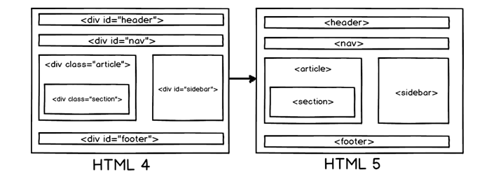

Below are more details of the HTML 5 elements which form the page structure.

* <header>: Represents header data of HTML.
* <footer>: Footer section of the page.
* <nav>: Navigation elements in the page.
* <article>: Self-contained content.
* <section>: Used inside article to define sections or group content in to sections.
* <aside>: Represent side bar contents of a page.

Datalist element in HTML 5 helps to provide autocomplete feature in a textbox

<input list="Country">

<datalist id="Country">

<option value="India">

<option value="Italy">

<option value="Iran">

<option value="Israel">

<option value="Indonesia">

</datalist>

## Can you explain CSS box model?

CSS box model is a rectangular space around a HTML element which defines border, padding and margin.

Border: - This defines the maximum area in which the element will be contained. We can make the border visible, invisible, define height and width etc.

Padding: - This defines the spacing between border and element.

Margin: - This defines the spacing between border and any neighboring elements.

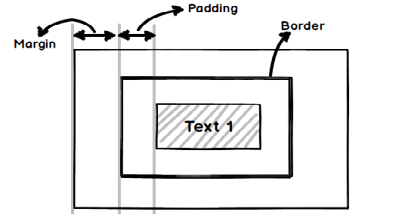

|  |  |  |
| --- | --- | --- |
|  | **Cookies** | **Local storage** |
| **Client side / Server side.** | Data accessible both at client side and server side. Cookie data is sent to the server side with every request. | Data is accessible only at the local browser side. Server cannot access local storage until deliberately sent to the server via POST or GET. |
| **Size** | 4095 bytes per cookie. | 5 MB per domain. |
| **Expiration** | Cookies have expiration attached to it. So after that expiration the cookie and the cookie data get’s deleted. | There is no expiration data. Either the end user needs to delete it from the browser or programmatically using JavaScript we need to remove the same. |

What is the difference between local storage and cookies?

use of local storage // something that is important.

<html>

<div>

Enter you name:

<br>

<input type = "text" id="yourName" size = "50">

<br><br>

<button onClick="setName()"> submit </button>

<button onClick="getName()"> Display </button>

<button onClick="removeName()"> remove </button>

<script>

function setName(){

var username = document.getElementById("yourName").value;

if(username === "") return false;

localStorage.setItem("name",username);

document.getElementById("yourName").value="Name saved";

}

function getName(){

if(localStorage.getItem("name" === null) ) return false;

document.getElementById("yourName").value = "Named saved as: "+localStorage.getItem("name");

}

function removeName(){

if(localStorage.getItem("name" === null) ) return false;

localStorage.removeItem("name");

document.getElementById("yourName").value="Name removed";

}

</script>

</div>

</html>

note:- disabled = true // in submit button can disabeled

## What are selectors in CSS?

Selectors help to select an element to which you want to apply a style. There are three types of selectors.   
class eg .  
id eg #  
elements eg h3,p,nav

## What is the use of column layout in CSS?

CSS column layout helps you to divide your text in to columns.

## What is local storage concept in HTML 5?

Many times we would like to store information about the user locally in the computer. For example let’s say user has half-filled a long form and suddenly the internet connection breaks off. So the user would like you to store this information locally and when the internet comes back.He would like to get that information and send it to the server for storage.

Modern browsers have storage called as “Local storage” in which you can store this information.

## What is the lifetime of local storage?

Local storage does not have a life time it will stay until either the user clear it from the browser or you remove it using JavaScript code.

## What is WebSQL?

WebSQL is a structured relational database at the client browser side. It’s a local RDBMS inside the browser on which you can fire SQL queries.

## Is WebSQL a part of HTML 5 specification?

No, many people label it as HTML 5 but it’s not part of HTML 5 specification. The specification is based around SQLite.

|  |
| --- |
| What is SVG? 1. SVG is the abbreviation for Scalable Vector Graphics and is recommended by W3C. 2. It is used to define vector-based graphics for the Web. 3. The graphics are defined in XML format. 4. An important quality of SVG graphics is that their quality is maintained even when they are zoomed or resized. 5. All the element and attributes of SVG files can be animated. |
| What are the advantages of SVG over other image format like JPEG or GIF? Following are the main advantages of using SVG over other image formats:  - It is possible to scale the SVG images. - They can be created and edited with any text editor. - The print quality of these image is high at any resolution. - It is possible to zoom the SVG images without any degradation in the quality. - SVG images can be searched, indexed, scripted, and compressed. |
| Differentiate between Canvas and SVG. The table below shows some important differences between Canvas and SVG:  - Canvas is resolution dependent while SVG is not. - Canvas does not provide any support for event handlers while SVG does. - Canvas is suitable for graphic-intensive games while SVG is not suitable for gaming. - Canvas is suitable for small rendering areas while SVG is suitable for large rendering areas like Google maps. |

|  |
| --- |
|  |
| What is HTML5 Web Storage? With HTML5, it is possible for the web pages to store the data locally in the user's browser. This web storage is much faster and secured than the cookies. Also, a larger amount of data can be stored without causing any adverse effect to the performance of the website.  The data here is not included with every server request. It is used ONLY when it is asked for. It is only that particular web page that can access the data stored by itself. |
| Differentiate between localStorage and sessionStorage objects. - **localStorage object** stores the data without an expiry date while **sessionStorage object** stores the data only for one session. - With **localStorage object,** data will not be deleted when the browser window is closed while the data is deleted when the browser window closes with **sessionStorage objects.** |
|  |

## What is the concept of Application Cache in HTML5? What are its advantages?

The Application Cache concept introduced by HTML5 means that a web application is cached, and accessible without an internet connection.  
  
**There are three advantages of Application Cache:**  
  
**1. Offline browsing -** Users can use the application when they're offline  
**2. Speed -** Cached resources load faster  
**3. Reduced server load -** The browser will only download updated/changed resources from the server

|  |
| --- |
| What is a Manifest file? A Manifest file is a simple text file that tells the browser what to cache and what not to cache.  There are three sections of a Manifest file:  1) **CACHE MANIFEST -** Files listed here are cached after they are downloaded for the first time. 2) **NETWORK -** Files listed here require a connection to the server, and are never cached. 3) **FALLBACK -** Files listed here specify fallback pages if a page is inaccessible. |
| What is a Web Worker? 1. A web worker is a JavaScript which runs in the background. It exists in external files. 2. It is independent of other scripts and does not affect the performance of the page. 3. Web workers are usually used for CPU intensive tasks. |

|  |
| --- |
|  |
| Which JavaScript objects are not accessible to web worker? Following JavaScript objects are not accessible to web worker:  1. The window object 2. The document object 3. The parent object |
|  |